# OPERATORS IN C++

# ARITHEMATIC OPERATORS:-

1. + (sum):

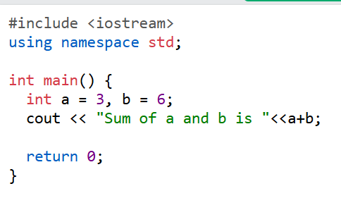

1. – (difference):

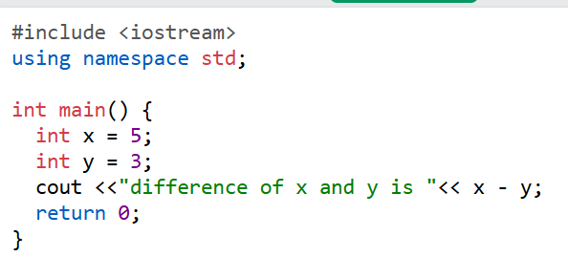

1. * (product):

1. / (divide):

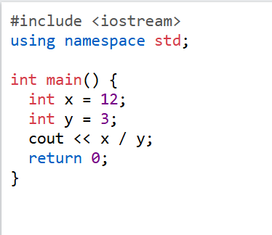

1. % (modulus):

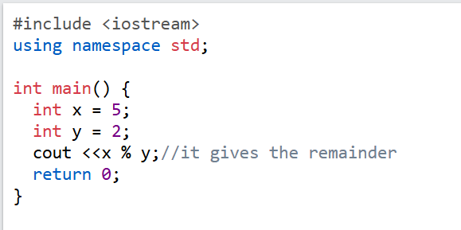

1. ++(Increment):

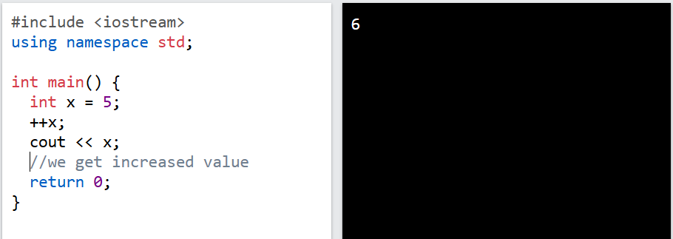

1. --(Decrement):

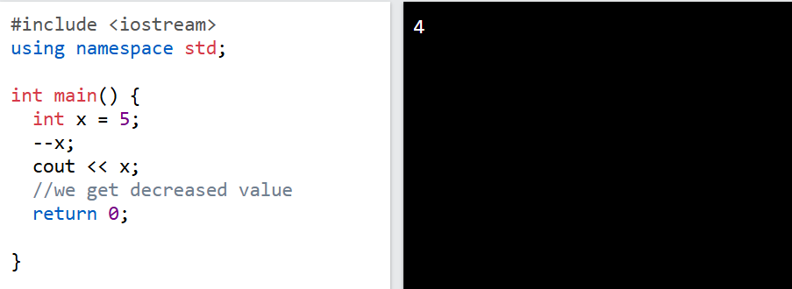

# ASSIGNMENT OPERATORS:-

1. **(**+=)

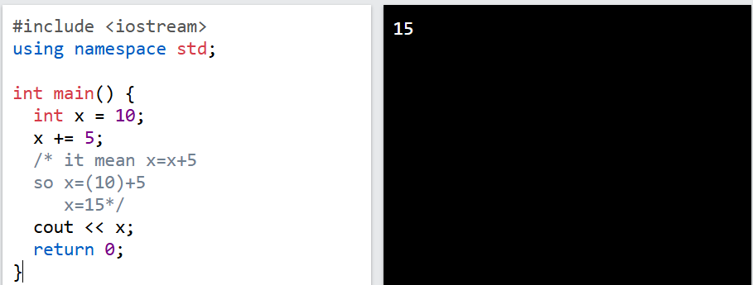

1. (-=)

1. (*=)

1. (/=)

1. (&=)

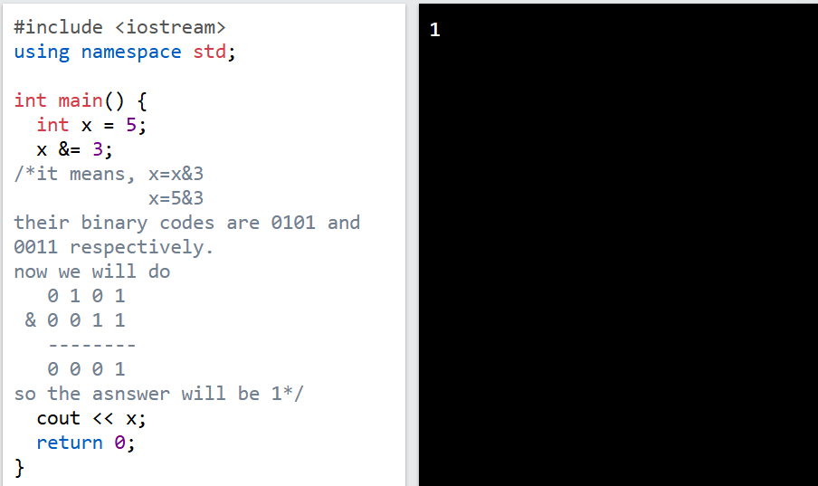

1. (|=)

1. (^=)

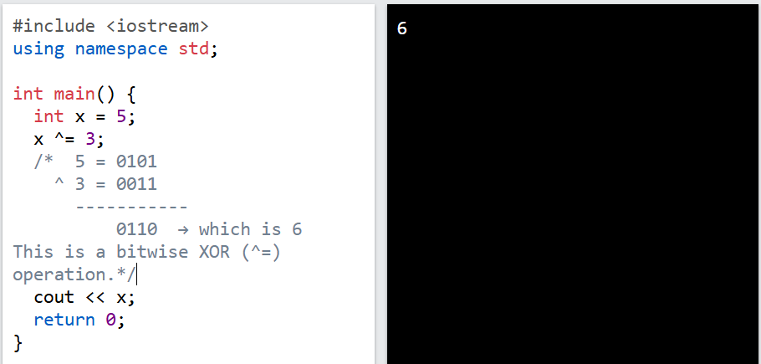

1. (>>=)

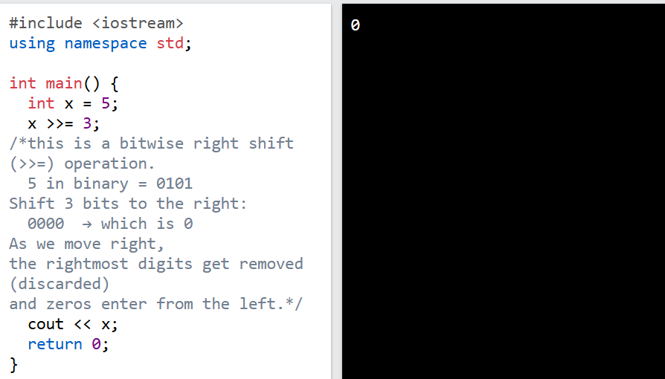

1. (<<=)

# COMPARISON OPERATORS

1. ==

1. !=

1. >

1. <

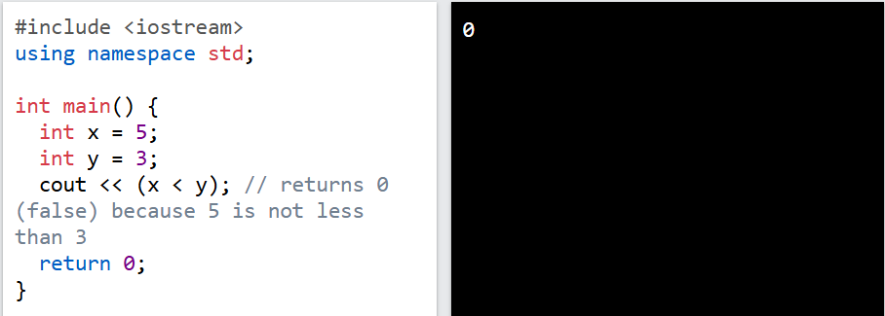

1. >=

1. <=

# LOGICAL OPERATORS

1. && (logic AND)

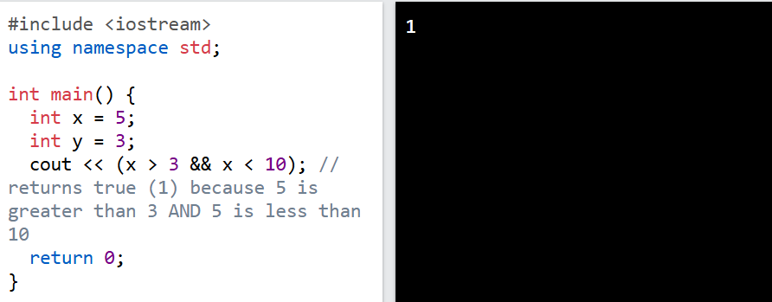

1. || (logic OR)

1. ! (logic NOT)

# Task:

